
Khaleel Ahmad
 +49 15563611714 |  khaleel.eu@gmail.com | Berlin, Germany

github.com/khaleel-git |  linkedin.com/in/khaleel-ahmad | khaleel.eu
Education
BTU Cottbus-Senftenberg, Germany Apr 2025 – Present Master of Science in Artificial Intelligence (Working Student eligible)
Relevant Coursework: Network and System Security, Distributed Computing in ML, Logic in Databases
Information Technology University, Pakistan Sep 2016 – Feb 2021
Bachelor of Science in Computer Science

Skills

Languages: Python (pytest), Java, C, C++, Bash, Zsh, HCL (terraform)
Databases: MSSQL, MySQL, PostgreSQL, MongoDB
DevOPS: Linux (Debian, Ubuntu, CentOS), Kubernetes, Docker, Git, Ansible, Terraform, CI/CD (GitHub Actions), GitLab CI,

Frameworks & Monitoring: SDLC, Test Automation, Flask, Django, Node.js, ReactJS, Prometheus, Grafana

Data Engineering: Apache Airflow (CI/CD & ETL Pipeline), PowerBi Dashboards
Cloud: VMware, AWS, GCP, Azure, IBM, Digital Ocean, Alibaba

Experience
Ericsson Aug 2022 – Feb 2025

Data (Platform) & Python Engineer
- Developed and maintained Python-based automated validation scripts using Pytest to verify data pipelines and MSSQL workflows, improving reliability and early defect detection.
- Integrated Pytest automation into CI/CD workflows to validate distributed data processing jobs and database operations before deployment.
- Automated MSSQL workflows with Python and pymssql, reducing data processing time by 30%.
- Provisioned distributed VMware server architecture on HPE virtual machines using Terraform and Ansible.
Hello App Jan 2020 – July 2022

Linux System Administrator & Python Developer
- Managed multi-cloud infrastructure for 50+ applications across AWS, GCP, Azure, DigitalOcean, Vultr & Linode, ensuring 99.9% SLA uptime and high availability.
- Deployed and administered 50+ websites using WHM/cPanel, Vesta, CloudPanel, and ISPConfig, streamlining web hosting operations.
- Deployed scalable WordPress and Python applications, enhancing cloud infrastructure efficiency and performance.

Projects
Tech Migration from Ericsson GSC China Mar 2023 – Jun 2024

Tech Stack: Python, Apache Airflow (Workflow Orchestration / CI/CD), AWS, MSSQL, Linux, Bash, On-prem VPS
- Migrated critical infrastructure and automated workflows from Ericsson GSC China to AWS and internal VPS infrastructure, ensuring zero-downtime system operations.
- Re-engineered data pipelines using Apache Airflow and Python, improving reliability and reducing manual intervention by 40%.
Infotainment Service Test Automation Framework Mar 2023 – Jun 2024

Tech Stack: Python, Pytest, Requests, GitLab CI/CD, Docker, Linux, Pytest-HTML
- Designed and implemented a scalable Python-based test automation framework to validate infotainment backend services (media, navigation, user preferences).
- Developed API-level automated test cases covering functional, regression, and negative scenarios using Pytest.
- Integrated automated tests into GitLab CI/CD pipelines, enabling continuous quality checks on every commit.
- Generated detailed HTML test reports and analyzed failures to improve system reliability and test coverage.
Delta Scanner | Ericsson/Jazz Mar 2023 – Jun 2024

Tech Stack: Python, pymssql, Custom Distributed Processing, Multiprocessing, XQuery
- Developed real-time monitoring solution using multiprocessing and custom distributed computing to analyze 30,000 XML files for parameter value changes.

Certifications


Certified Kubernetes Administrator (CKA)

Containerized Applications on AWS
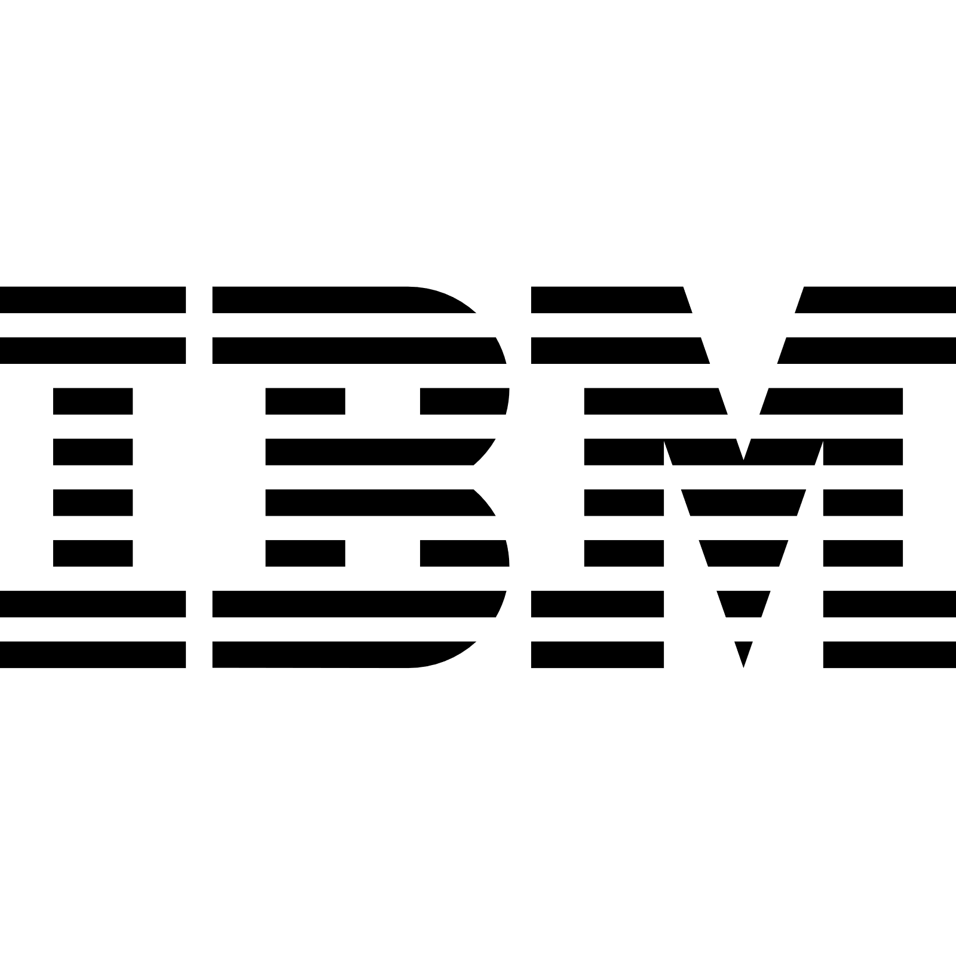
Python Data Structures
Continuous Integration and Continuous Delivery (CI/CD)

